Name | : | M.Ajith
Project Name | : | Real Calculator

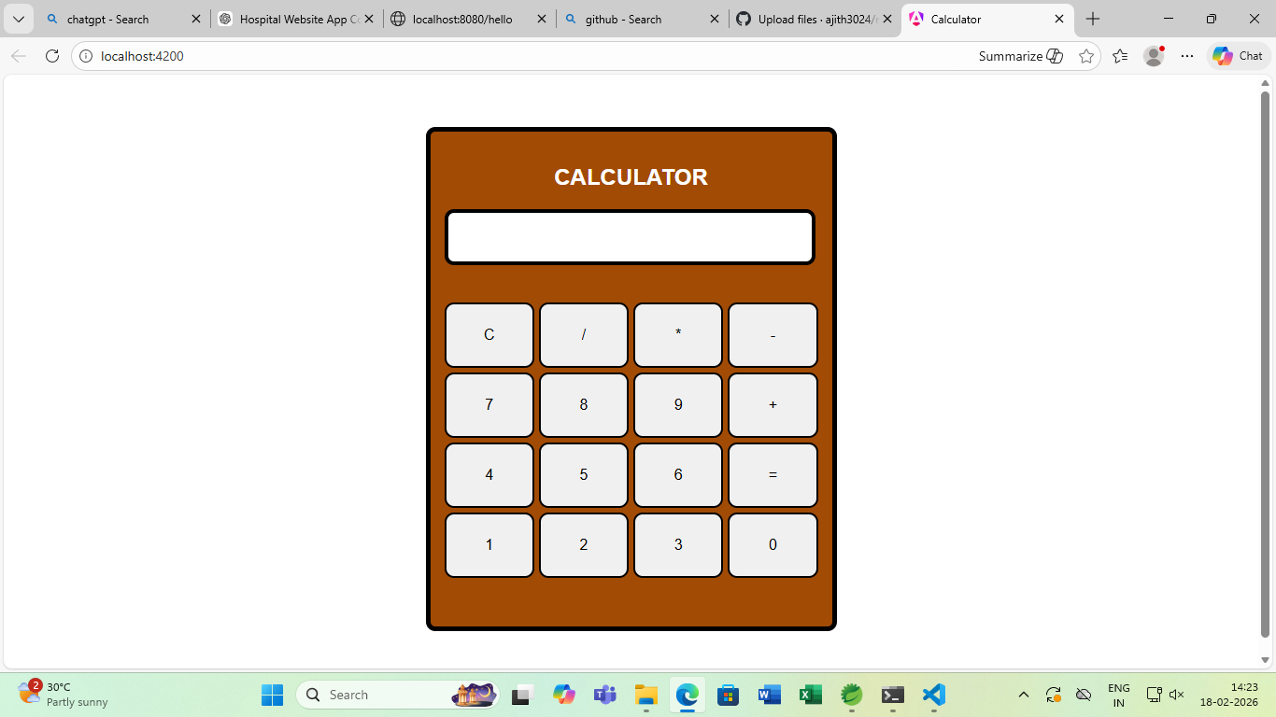

✅ Short Introduction (Opening Lines)
“My project is a Real-Time Calculator web application developed using HTML, CSS, and Angular framework. This calculator performs basic arithmetic operations like addition, subtraction, multiplication, and division with instant results on the same page.”

✅ Objective of the Project
- To build a responsive calculator web app
- To understand Angular components and data binding
- To perform real-time arithmetic calculations
- To improve frontend development skills

✅ Technologies Used
- HTML – To create the structure of the calculator
- CSS – To design and style the calculator UI
- Angular – To handle logic, events, and real-time calculation

✅ How It Works (Explain Flow)
- User enters two numbers
- User selects an arithmetic operation (+, −, ×, ÷)
- When the button is clicked, Angular processes the logic
- Result is displayed instantly without page reload
- Input validation prevents wrong entries

✅ Key Angular Concepts Used
- Components
- Data Binding
- Event Binding (button click)
- Two-way binding (ngModel)
- Functions for calculation logic

✅ Features
- Simple and user-friendly interface
- Real-time result display
- Input validation
- Responsive design
- Fast calculation

✅ Conclusion (Closing Lines)

-----------------------------------------------------------------------------------------------
Project Name | : | Group Chat

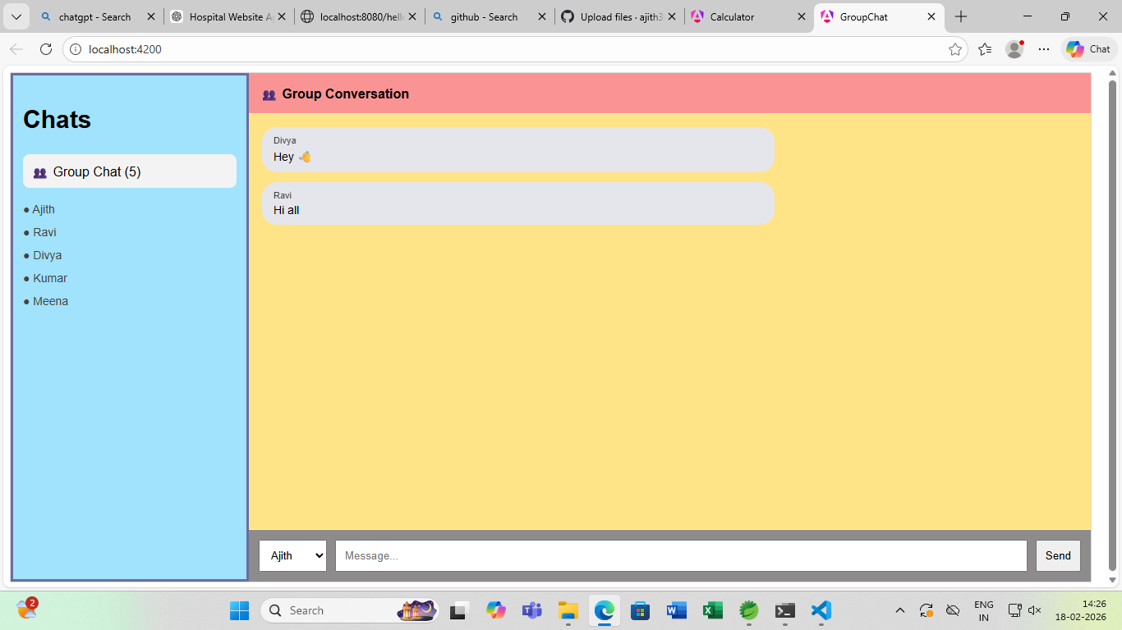

GROUP CHAT
1️. This project is a web-based Group Chat Application.
2️. It is developed using HTML for structure, CSS for design, and Angular for application logic.
3️. The screen is divided into two main sections:
- Left panel → Chat list and user names
- Right panel → Group conversation window
4️. Multiple users can send messages to the same group chat.
5️. A user is selected from a dropdown before sending a message.
6️. Messages are typed in the input box at the bottom.
7️. When the Send button is clicked, the message appears instantly in the chat window.
8️. Each message is displayed with the sender name and message bubble style.
9️. Angular components are used to build different parts.
10. Angular services are used to store and share messages between components.
11. Data binding is used to update messages in real time without page reload.
12. CSS is used to style chat panels, message bubbles, and layout colors.

Project Name : login page

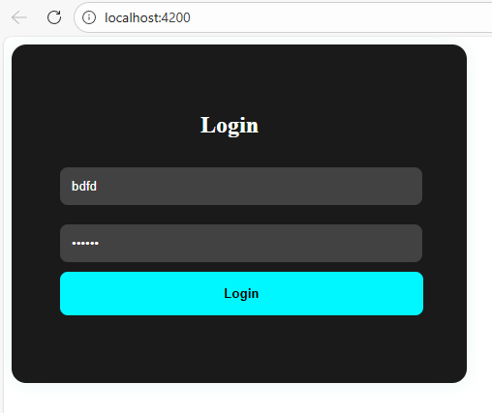
📌 Project Description (Points)
- This project is a creative login page developed using Angular, HTML, and CSS.
- It uses Angular Standalone Component architecture (without NgModule).
- The login form contains:
  - Username field
  - Password field
  - Login button
- It uses two-way data binding (ngModel) to connect input fields with component variables.
- Form validation is implemented using:
  - required validation
  - Disabled login button when form is invalid
- When the user clicks the Login button:
  - The program checks the entered credentials
  - Displays success message if correct
  - Displays error message if incorrect

- This project demonstrates basic Angular concepts like:
  - Data binding
  - Event binding (ngSubmit)
  - Form handling
  - Component-based architecture
- It is suitable for beginners and academic mini projects.

